***Select Parallel execution***

Example table:

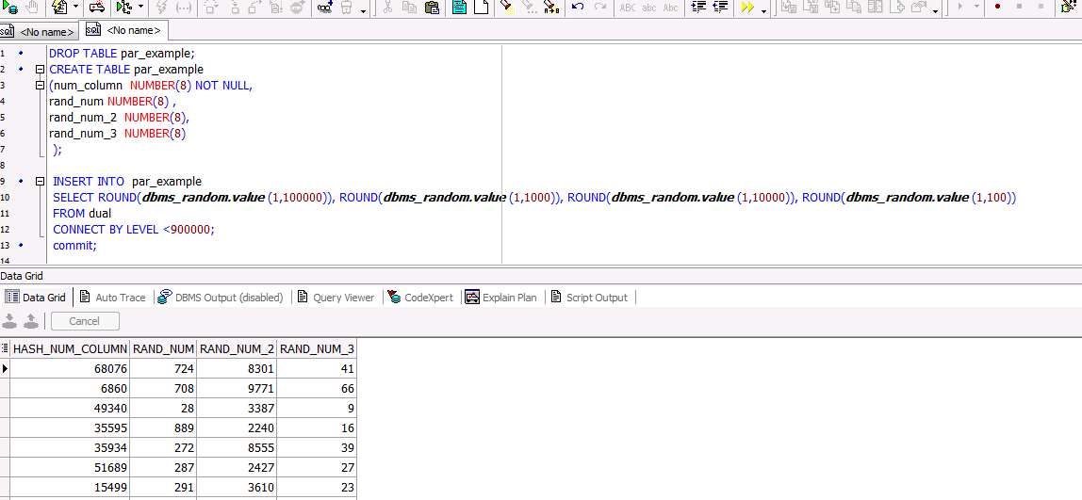

NOTE: parallel degree for tables

ALTER TABLE customers PARALLEL 4

Select without paralleling:

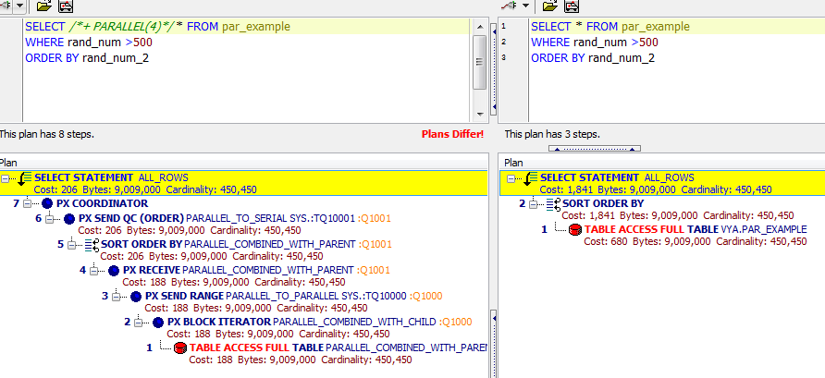

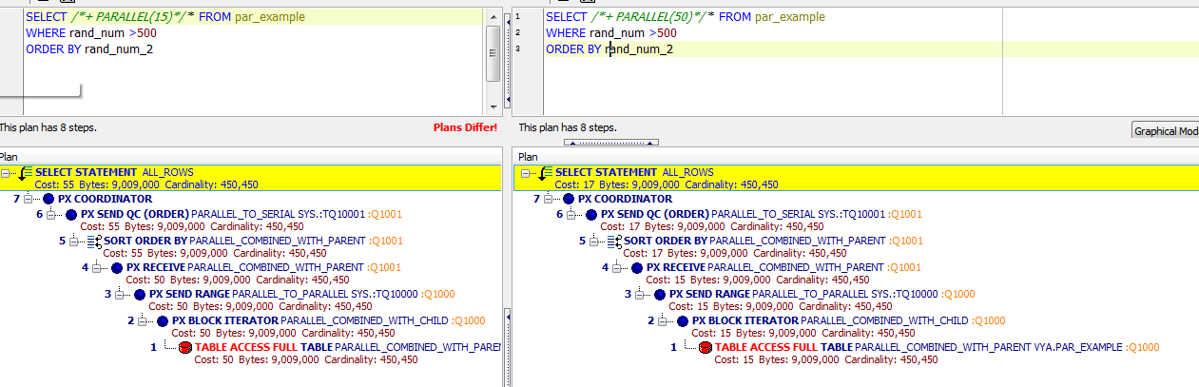

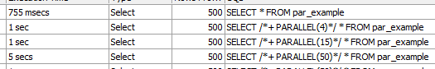

|  |  |  |
| --- | --- | --- |
| Processes | Execution Time, secs | Cost |
| 1 | 0.755 | 1841 |
| 4 | 1 | 206 |
| 15 | 1 | 55 |
| 50 | 5 | 17 |

***Parallel DML***

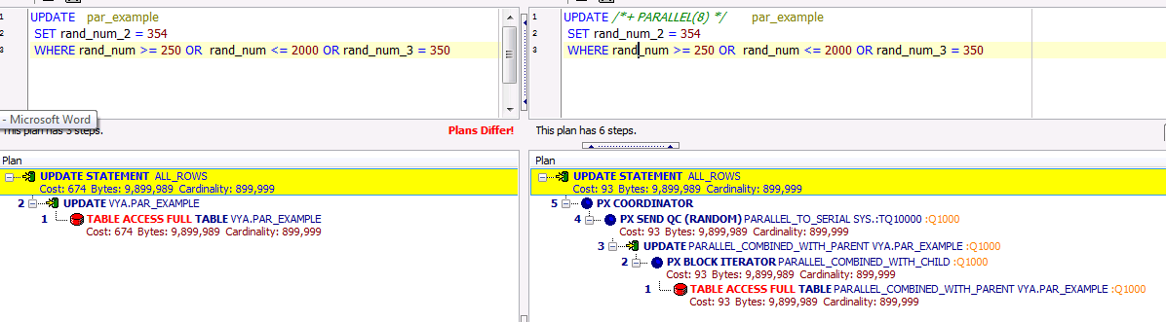

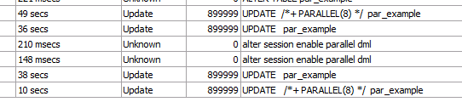

Without commit or rollback of the changes it is not possible to work with object.

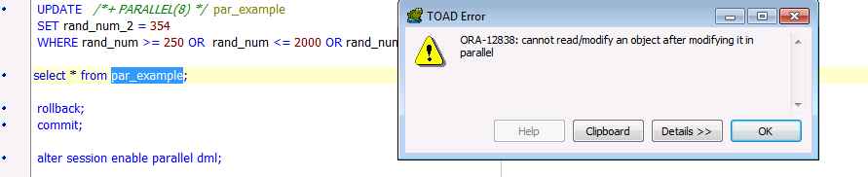

|  |  |  |
| --- | --- | --- |
| Processes | Execution Time, secs | Cost |
| 1 | 38 | 674 |
| 8 | 10 | 93 |
|  |  |  |
|  |  |  |

***Parallel DDL***

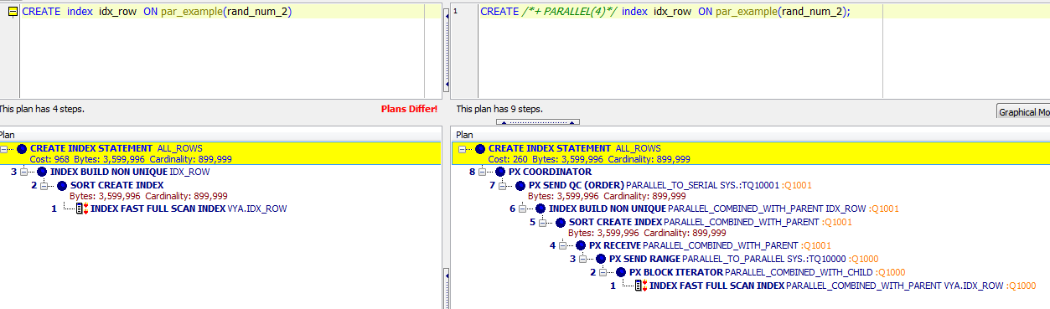

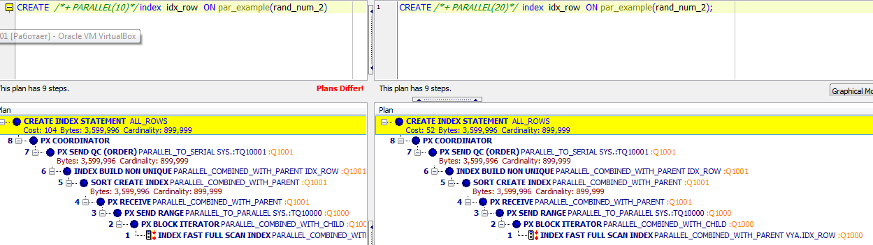

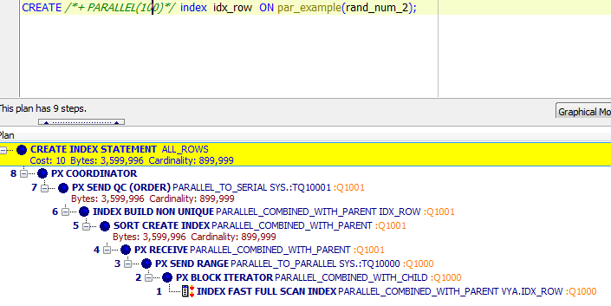

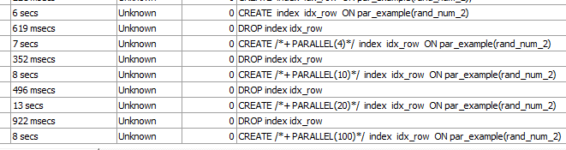

|  |  |  |
| --- | --- | --- |
| Processes | Execution Time, secs | Cost |
| 1 | 6 | 968 |
| 4 | 7 | 260 |
| 10 | 8 | 104 |
| 20 | 13 | 52 |
| 100 | 8 | 10 |